**AIM: -**

Local Tourism of the city of **Badami.**

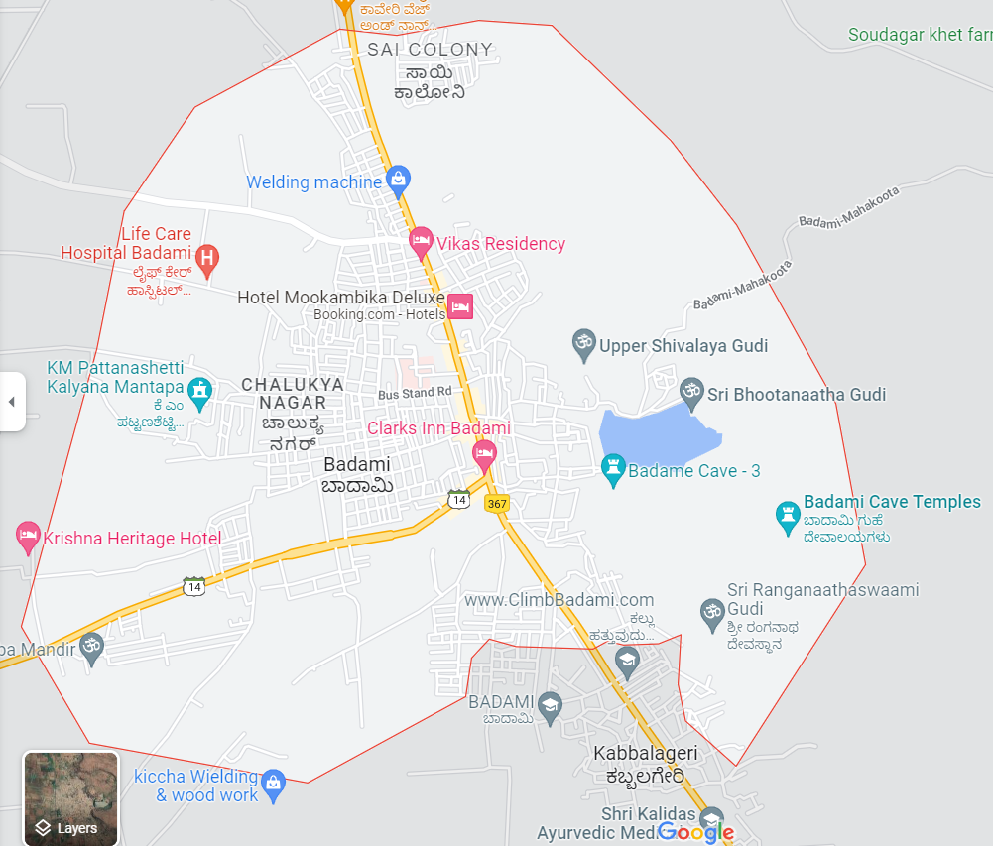

**CHAPTER 1**

**BANASHANKARI AMMA TEMPLE**

**HISTORY**

Historians have dated the original temple to the 7th century AD - the Kalyani Chalukya period to Jagadekamalla I in 603 AD (according to epigraphic inscriptions) who installed the image of the goddess. The present refurbished temple was built in 1750, by Parusharam Agale, a Maratha chieftain.

It is also said that the original temple was in existence even before the reign of the Chalukyas who gave royal favour to the beliefs of the Vaishnava, Shaivaite, Jain and Shakta religious orders. They worshipped Banashankari as a form of Shakti, their Supreme Goddess. Epigraphic inscriptions mention that Jagadekamalla I renovated the temple with several additions. Another inscription in Kannada language on a pillar located on the northern side of the temple dated to 1019 AD, describes the bravery of the Rashtrakuta king Bhimadeva. The *Deepa Stamba*s (lamp pillar) are seen at the entrance to the temple; the construction of these, as per an inscription, are ascribed to the warrior Ketimayya.

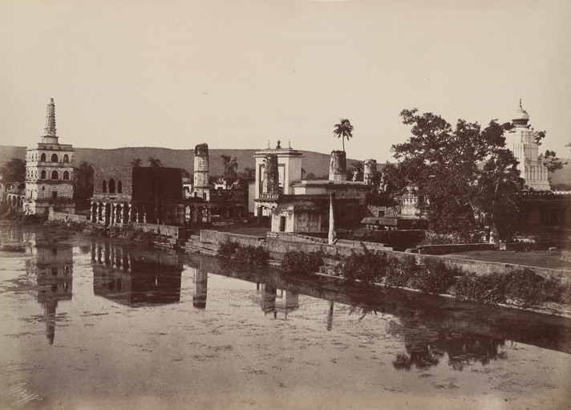

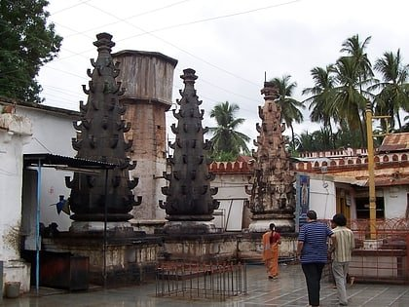

**BANASHANKARI MURTY**

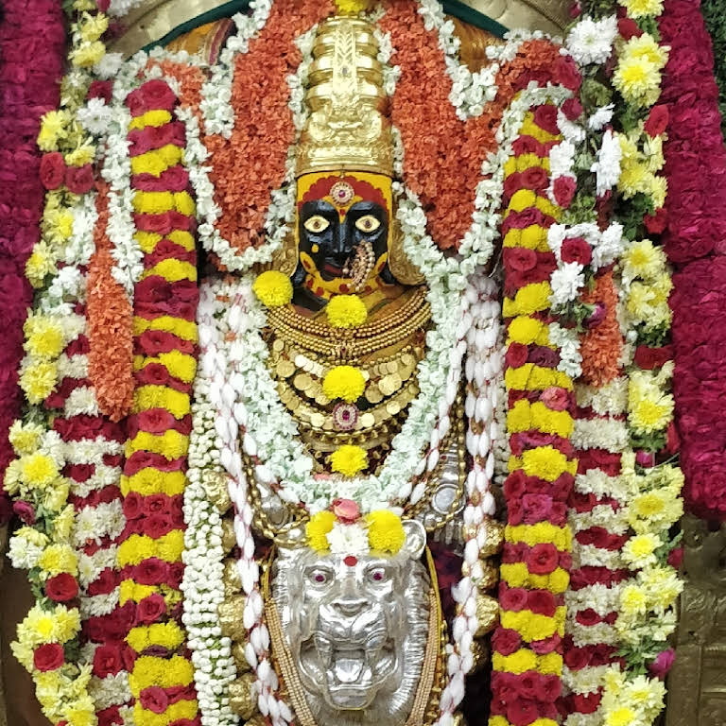

Banshankari or Vanashankari is made up of two Sanskrit words: *vana* ("forest") and *Shankari* ("the consort of Shiva, Parvati"). The temple is popularly called Vanashankari since it is located in the Tilakaaranya forest. The transformation of *vana-* to *bana-* reflects a common loanword adaptation in Kannada from Sanskrit words. The other popular name given is Shakambhari, which means the "Vegetable Goddess". It is formed by joining of two words *Shaka* and *Ambari*. In Sanskrit, *Shaka* means vegetables or vegan food and *Ambari* means "one who wears or bears to the hungry". A further elaboration is that "Shakambhari" comes from *Shakam* joined with the root *Bhri* (Shaka = vegetables or food and root bhri = to nourish).

Locals also call the temple goddess as *Balavva*, *Banadavva*, *Sunkavva*, *Shiravanthi*, *Chowdamma* and *Vanadurge*. It is said that Banashankari is the sixth incarnation of the warrior-goddess Durga.

**GOAL**

The scriptures Skanda Purana and Padma Purana state that the demon Durgamasura harassed the local people constantly. Answering the prayers of the Devas (demi-gods) who appealed to God through a sacrifice to protect them from Durgamasura, the Lord directed the goddess Shakambari to help the people. The goddess appeared through the fire of the Yagna (fire-sacrifice) in the form of the goddess Shakambari. She then killed the demon after a fierce encounter and restored peace in the region. Banashankari is considered as the incarnation of goddess Parvati, who is the consort of God Shiva.

**RATHA YATRA**

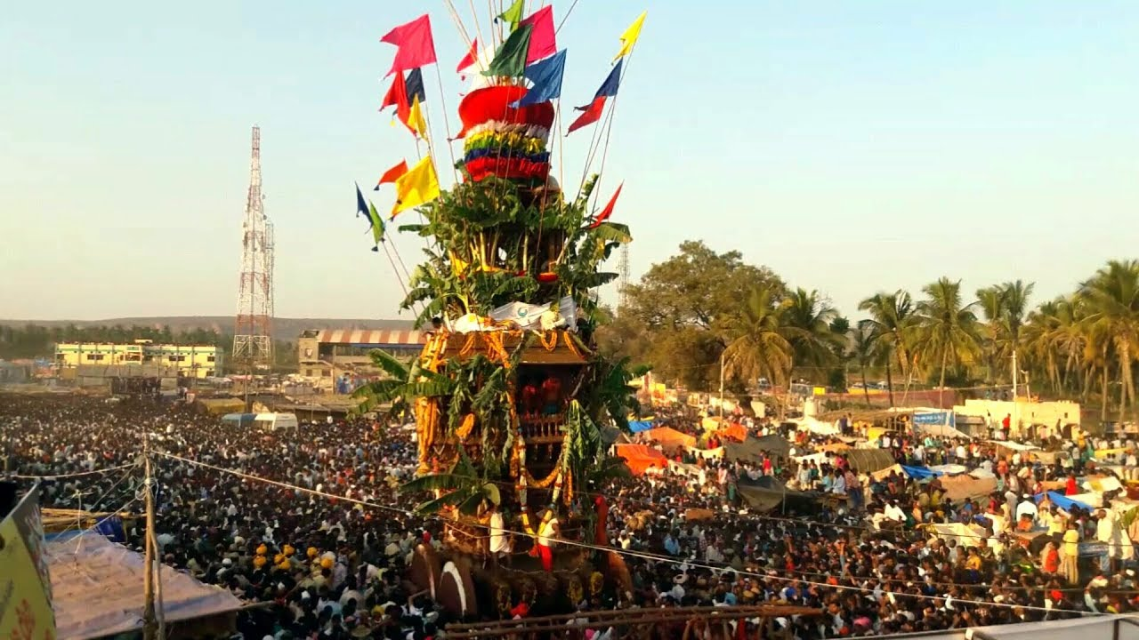

The *Rath Yatra* or chariot festival of the goddess held every year starts on the full moon day of the Hindu month Pausha (January) in which the temple goddess Parvati is taken in the chariot (a movable shrine) in a procession along the streets of the Cholachagudd village from the temple gate to Padhkatte, another nearby sculpture. The Rath yatra is witnessed by thousands of people, irrespective of their caste and creed from across the state. To see this cultural and religious extravaganza, people from adjacent villages come in colorfully decorated carts.

During the religious celebrations in Hindu temples, images of the gods and goddesses worshipped in the temples, are taken on large wooden chariots called *ratha*s and drawn in a pageant by the devotees. The chariots are generally 5–6 m (16.4–19.7 ft) in height and weigh several tonnes. Huge wheels of solid wood are fixed to the chariot. The chariot is pulled by specially trained men. The chariot appears like a mini temple or shrine as it invariably has figurines of gods and goddesses carved on it.

**LOCATION**

**Address**: SH 57, **Banashankari**, Cholachagudda, Karnataka 587201, **Badami**, India ; **Timings**: 24-hrs Details ; Phone: +91-9480024568 ; Tags: Temple, Family And Kids.

Phone: +91-9480024568

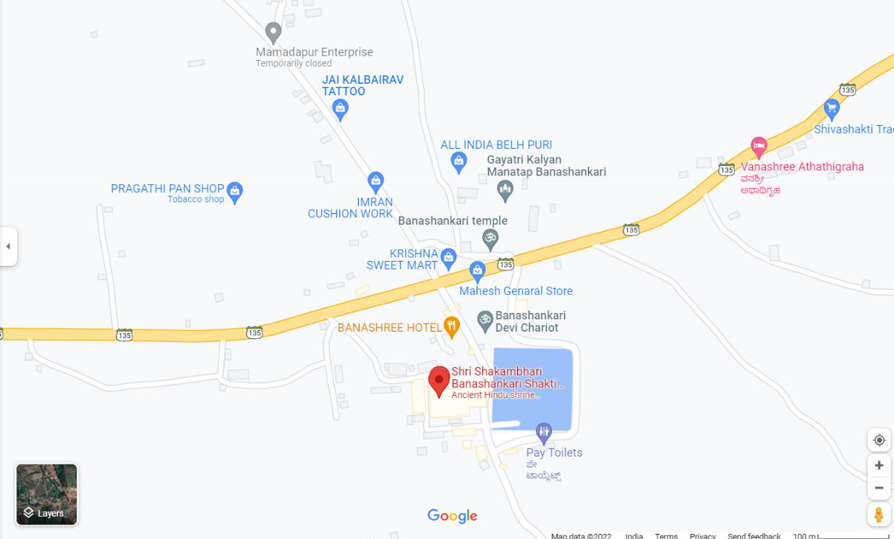

**CHAPTER 2**

**BADAMI CAVES**

The **Badami cave temples** are a complex of Hindu and Jain cave temples located in Badami, a town in the Bagalkot district in northern part of Karnataka, India. The caves are important examples of Indian rock-cut architecture, especially Badami Chalukya architecture, and the earliest date from the 6th century. Badami is a modern name and was previously known as Vataapinagara, the capital of the early Chalukya dynasty, which ruled much of Karnataka from the 6th to the 8th century. Badami is situated on the west bank of a man-made lake ringed by an earthen wall with stone steps; it is surrounded on the north and south by forts built in later times.

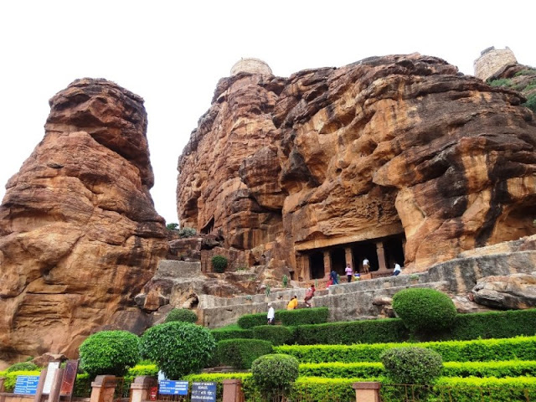

**HISTORY**

The cave temples, numbered 1 to 4 in the order of their creation, in the town of Badami – the capital city of the Chalukya kingdom which is a temple dedicated to Vishnu. The inscription, written in the old Kannada language, has enabled the dating of these rock cave temples to the 6th century. This makes the cave the oldest firmly dated Hindu cave temple in India.

 "Evolution of Temple Architecture – Aihole-Badami-Pattadakal" in the Malaprabha river valley, considered a cradle of temple architecture that formed the model for later Hindu temples in the region.

The first three caves feature sculptures of Hindu icons and legends focusing on Shiva and Vishnu, while Cave 4 features Jain icons and themes.

**TEMPLE CAVES**

The Badami cave temples are carved out of soft Badami sandstone on a hill cliff. The cave temples are linked by a stepped path with intermediate terraces overlooking the town and lake. The cave temples are labelled 1–4 in their ascending series; this numbering does not reflect the sequence of excavation sequence of excavation.

**CAVE 1**

Cave 1 is about 59 feet (18 m) above ground level on the north-west part of the hill. Access is through a series of steps that depict carvings of dwarfish ganas in different postures as if they hold the cave floor. The verandah, with an inner measurement of 70 feet (21 m) by 65 feet (20 m), has five columns sculpted with reliefs of flower garlands, foliage and jewelry.

* Nataraja Carving
* Mahisasura Mardhini Carving
* Harihara Carving
* Ardhanareshwara Carving

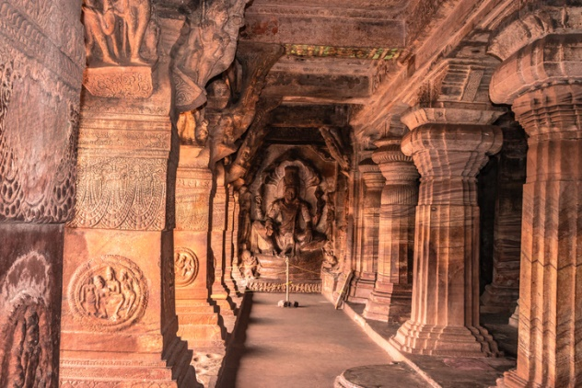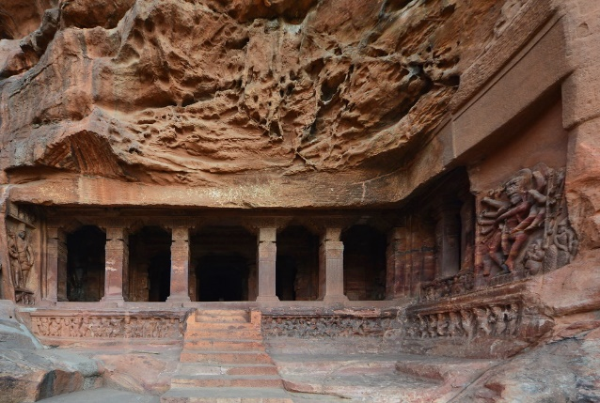

**CAVE 2**

Cave 2 is above and to the east of Cave 1 and faces north. It was created in late 6th or early 7th century. It is smaller than Cave 1, somewhat similar in terms of its floor plan, but it is dedicated primarily to Vishnu. The cave entrance is a verandah divided by four square pillars with ends as half pillars, all carved out of the monolithic stone face. The pillars have decorative carvings with frieze of *ganas* (mythical dwarfs) with various facial expressions.

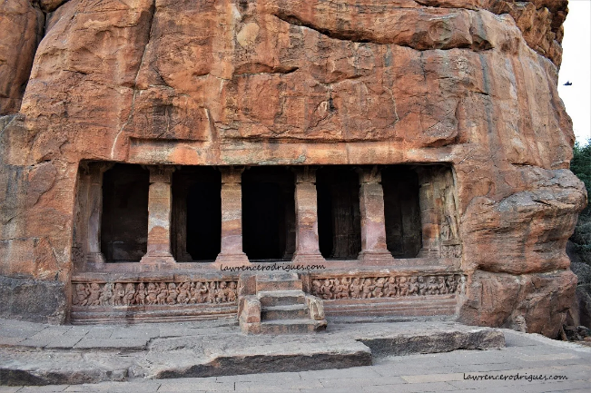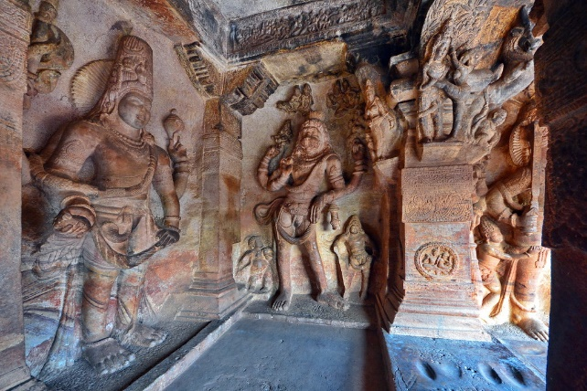

**CAVE 3**

Cave 3 is earliest dated Hindu temple in the Deccan region. It is dedicated to Vishnu; it is the largest cave in the complex. It has intricately carved friezes and giant figures of Trivikrama.

Anantasayana, Vasudeva, Varaha, Harihara and Narasimha. Cave 3's primary theme is Vaishnavite, though it also shows Harihara on its southern wall – half Vishnu and half Shiva shown fused as one, making the cave important to Shaivism studies.

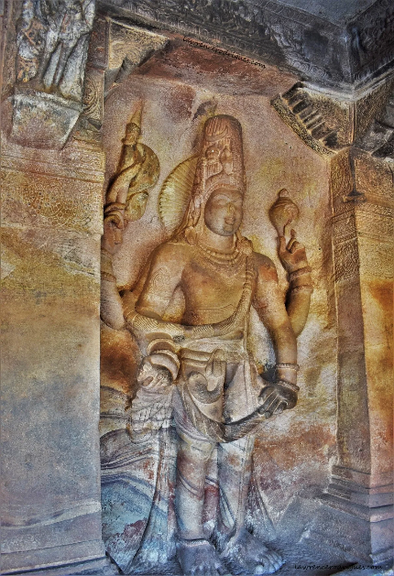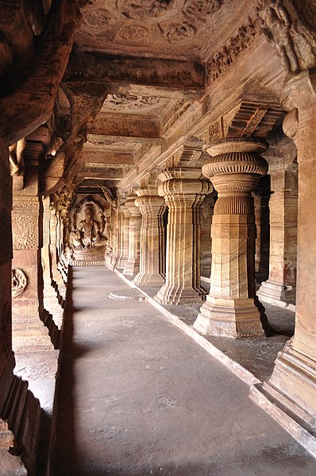

**CAVE 4**

Located immediately next to and east of Cave 3, Cave 4 floor is situated about 10 feet lower and is the smallest of the four. It is dedicated to Tirthankaras, the revered figures of Jainism.

Like the other caves, Cave 4 features detailed carvings and a diverse range of motifs. The cave has a five-bayed entrance with four square columns – each with brackets and capitals.

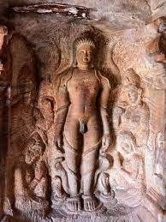

**ADDRESS:**

Badami Caves, Badami Bagalkot District, Karnataka-587201, India

**PHONE NUMBER:**

+91-0843344334

**TIMING:**

09:00AM-05:30PM

**LOCATION**

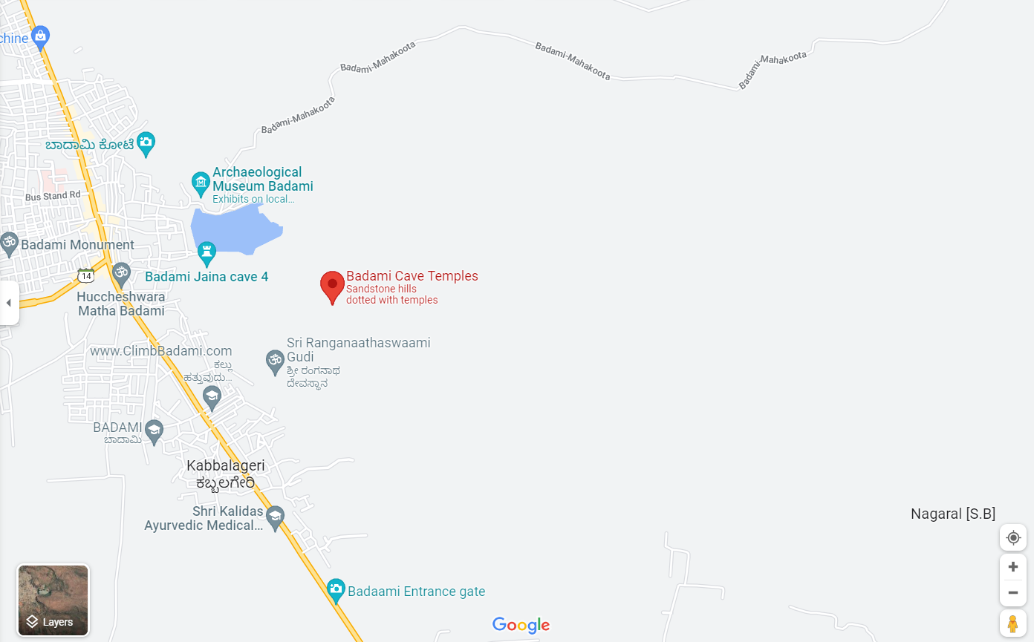

**CHAPTER 3**

**BADAMI FORT**

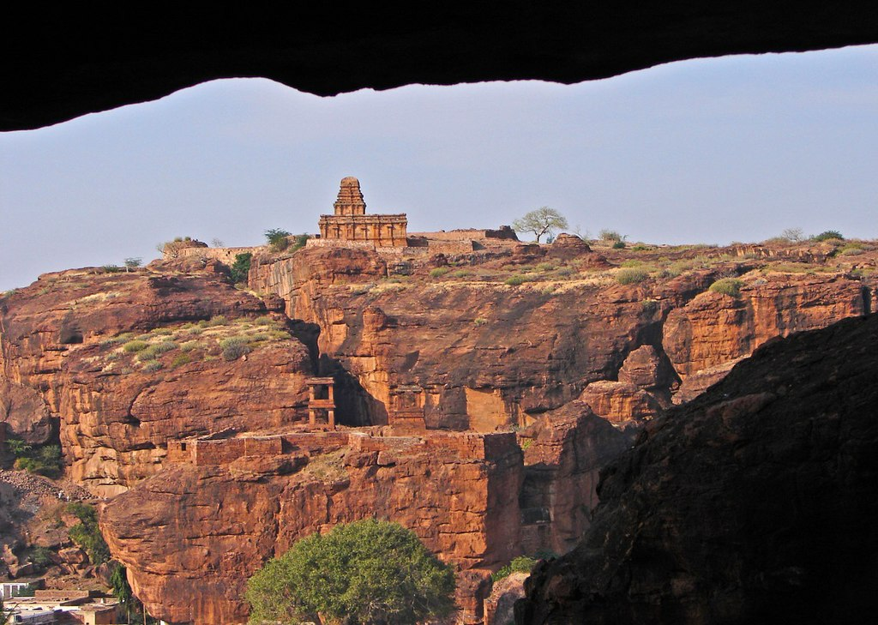

**HISTORY**

Badami Chalukyas was founded in CE 540 by Pulakeshin I (CE 535–566), an early ruler of the Chalukyas is generally regarded as the founder of the Early Chalukya line. An inscription record of this king engraved on a boulder in Badami records the fortification of the hill above "Vatapi" in 544. Pulakeshin's choice of this location for his capital was likely dedicated by strategic considerations since Badami is protected on three sides by rugged sandstone cliffs. His sons Kirtivarman I (CE 567–598) and his brother Mangalesha (CE 598–610) constructed the cave temples. The Agastya lake (formerly Vatapi lake) is a man-made lake, a water infrastructure completed in the 7th-century, likely as a strategic source of water for the capital and around which many Hindu temples were constructed. Badami has eighteen inscriptions with important historical information. The first Sanskrit inscription in old Kannada script, on a hillock date back to 543 CE, from the period of Pulakeshin I (Vallabheswara), the second is the 578 CE cave inscription of Mangalesha in Kannada language and script and the third is the Kappe Arabhatta records, the earliest available Kannada poetry in *tripadi* (three line) metre. one inscription near the Bhuthanatha temple also has inscriptions dating back to the 12th century in Jain rock-cut temple dedicated to the Tirtankara Adinatha.

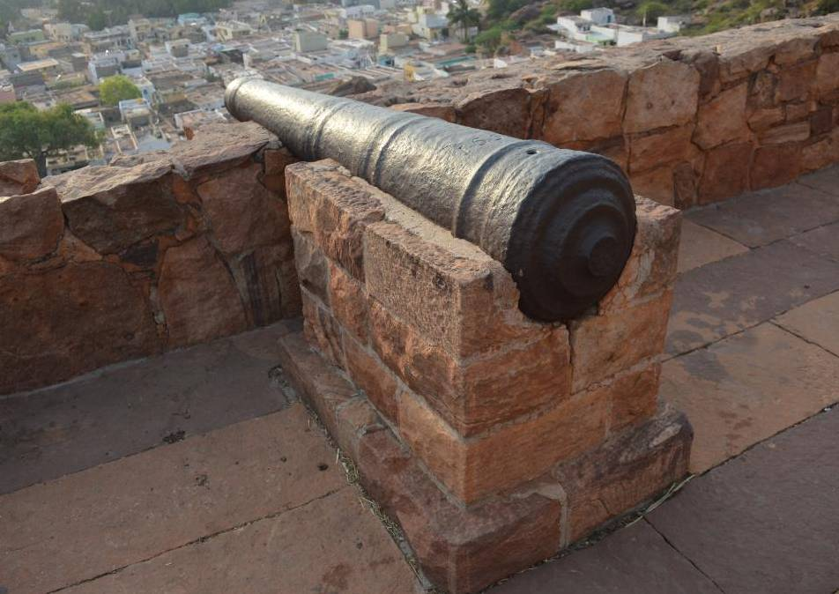

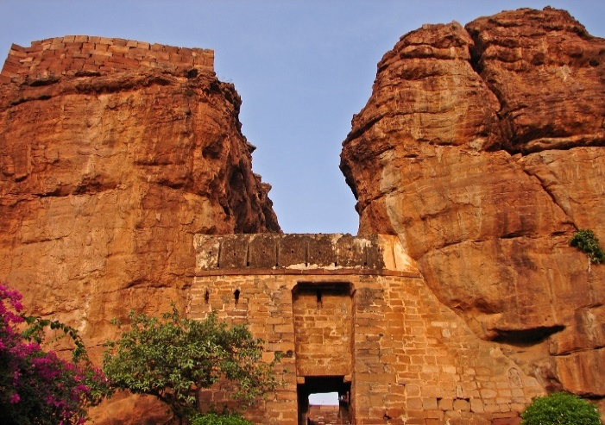

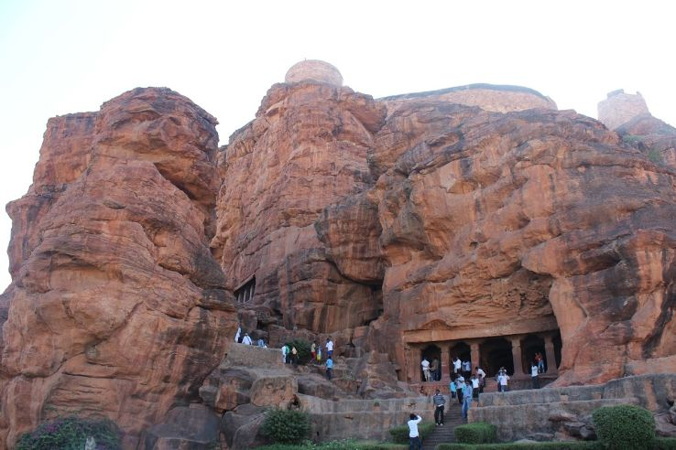

**DEMOGRAPHICS**

As of 2011 Indian Census, Badami had a total population of 30,943, of which 15,539 were males and 15,404 were females. Population within the age group of 0 to 6 years was 3,877. The total number of literates in Badami was 22,093, which constituted 71.4% of the population with male literacy of 78.1% and female literacy of 64.7%. The effective literacy rate of 7+ population of Badami was 81.6%, of which male literacy rate was 89.7% and female literacy rate was 73.6%. The Scheduled Castes and Scheduled Tribes population was 4,562 and 1,833 respectively. Badami had 6214 households in 2011.

As of the 2001 Indian census, Badami had a population of 25,851. Males constituted 51% of the population and females 49%. Badami had an average literacy rate of 64.8%, comparable to the national average of 65%; with 59% of the males and 41% of female’s literate. 14% of the population was under 6 years of age.

The main language is Kannada.

**TRANSPORT**

The nearest airport is Hubballi about 105 kilometers away. It is on the Hubli–Solapur rail route, and the rail station is 5 kilometers from the town. It is also connected by road to Hubli and Bijapur. Badami is reachable from Bangalore by a 12-hour bus ride, or by a direct train "Solapur Gol Gumbaz Exp (train no. 16535)" or with a combination of an overnight train journey from Bangalore to Hospet followed by a short bus ride from Hospet to Badami. Another train journey could be from Bangalore to Hubli (8–9 hours) and then a bus ride to Badami (3 hours). Badami is around 110 km from Hubli. Local transport is by auto-rickshaws, and city buses.

**BY ROAD**

Badami has a road network that spreads out to a number of towns and cities of Karnataka. There are a lot of buses that travel between Badami and several other towns and cities in Karnataka. Private cars, cabs or other vehicles are also available for hire from big cities like Bengaluru (Bangalore) or Mysuru (Mysore) to reach Badami.

**CLIMBING**

Badami's red sandstone cliffs are popular amongst local and international climbers. This is great location for free sport climbing and bouldering. The cliffs have horizontal crack systems, like Gunks. There are over 150 bolted routes and multiple routes for free climbing. Gerhard Schaar, a German Climber and Pranesh Manchaiah, a local climber from Bangalore, were instrumental in setting up the sport routes driving a project called 'Bolts for Bangalore'. National Rock Climbing centre, Manager Rajendra Hasabavi in Banshankari Road by General Thimayya National Academy of Adventure, Department of Youth Empowerment and Sports, Govt.of Karnataka is conducting various rock climbing and Adventure Camps.

**LOCATION**

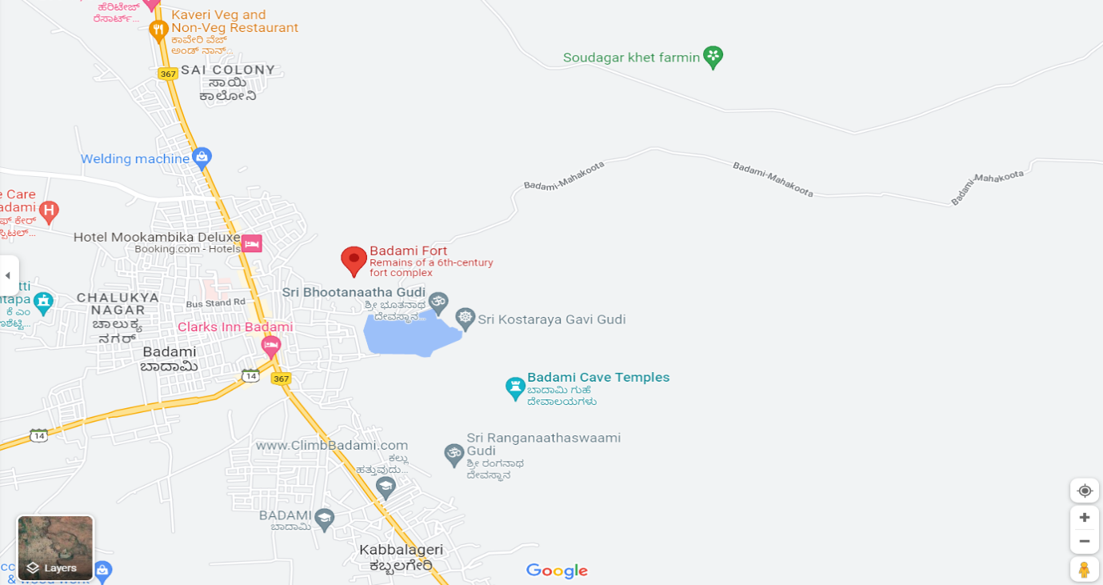

**CHAPTER 4**

**BHUTHANATHA TEMPLE**

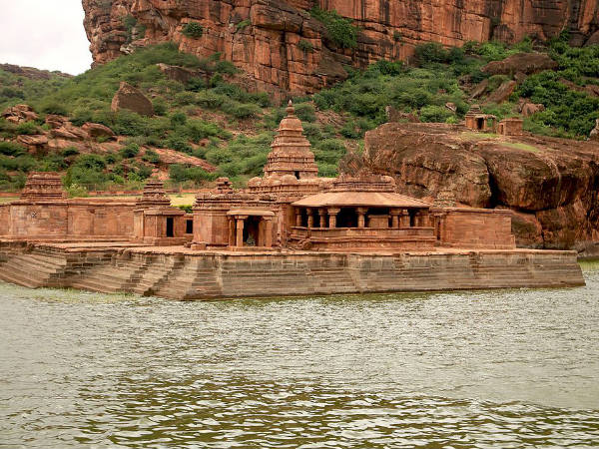

**HISTORY**

The **Bhutanatha group of temples** are 7th to 12th century Hindu temples to the east of Agastya lake in Badami, Karnataka state, India. It consists of two subgroups – one called the **East Bhutanatha group** or **Bhutanatha main group** from 7th to 8th-century mostly in the Dravida architecture style; the other called the **North Bhutanatha group** or **Mallikarjuna group** from 11th to 12th-century mostly in the Nagara architecture. The former illustrates the Badami Chalukya architects, the latter along with the nearby Yellamma temple the Kalyani Chalukya architects.

The Bhutanatha main group (700–725 CE) is the older set of Hindu shrines to the east of the Agastya Teertha. The oldest temple in this group is the main large temple. It has a gudha-mandapa with four massive central pillars (partly octagonal, cubical, and rounded on a lathe). This mandapa connects to a smaller square-plan sanctum with a Shivalinga. On the top of the sanctum is the Dravida-style *tritala* superstructure (three storeys). The lower part consists of a padabandha and kumbha. The vimana walls has karnas with *Brahmakanta*-style pilasters. The wall's nasis depict heads of kinnaras and gandharvas. The second storey of the superstructure repeats the lowest larger storey, and the third storey is half of the second in size, and again repeats the same elements in a rhythmic form. A square vedic topped with a short shikhara completes the superstructure.

The image niches on the wall of the shrine and the hall are now empty though some decorative elements like *makharas* (mythical beast) with long tails remain. The mandapa has *jali* (perforated windows for light into the inner mantapa). On either side of the foot of the shrine doorway is an image of goddess Ganga on her vehicle, the *makara*, on the right, and on the left, that of goddesses Yamuna riding the tortoise. There is no dedicatory block upon the lintel. Another artwork found nearby include Ganesha and Mahisasuramardini. A notable feature here is the inscription on the outer wall of the temple, which announces a gift from a Paingara family to the Sridharbuteswara (likely an epithet of the deity). This inscription can be dated to about the late 9th-century. This suggests the main temple was in active use at the time.

The porch pillars have a square cross section that transforms into an octagonal cross section. Outside, there is a stepped *ghat* for the devotees and pilgrims. The smaller shrines are ruined and were added later, likely through late 8th-century. To the east of the complex, on a boulder, are four Shaiva reliefs with unusual architectural details – these are impressions of four architectural styles of Shiva sanctum with panchakuta superstructure set on a square plan. These can be dated to the late 7th or early 8th-century and help establish that this temple complex was a Shaiva complex from its origin.

To the north of the main temple is a small shrine which, proposed Henry Cousens in 1923, was originally consecrated for Vishnu. At some point, the temple was adopted by the followers of Lingayatism who built an outer hall and installed a Nandi (vehicle of Shiva) and a Shiva *linga* inside the sanctum.

|  |  |
| --- | --- |
| **Bhutanatha group of temples, Badami** | |
| [Bhutanatha temple complex at Badami](https://en.wikipedia.org/wiki/File:Bhutanatha_temple_in_Badami,_Karnataka,_India.jpg)  7th to 8th century Hindu temples complex | |
| **Religion** | |
| [**Affiliation**](https://en.wikipedia.org/wiki/List_of_religions_and_spiritual_traditions) | [Hinduism](https://en.wikipedia.org/wiki/Hinduism) |
| [**Deity**](https://en.wikipedia.org/wiki/Deity) | [Shiva](https://en.wikipedia.org/wiki/Shiva) |
| **Governing body** | [Archaeological Survey of India](https://en.wikipedia.org/wiki/Archaeological_Survey_of_India) |
| **Location** | |
| **Location** | [Badami](https://en.wikipedia.org/wiki/Badami), [Karnataka](https://en.wikipedia.org/wiki/Karnataka) |
| [Saavira](https://en.wikipedia.org/wiki/File:India_relief_location_map.jpg)  Saavira  Shown within India | |
| [**Geographic coordinates**](https://en.wikipedia.org/wiki/Geographic_coordinate_system) | [15°55′15″N 75°41′16″E](https://geohack.toolforge.org/geohack.php?pagename=Bhutanatha_group_of_temples,_Badami&params=15_55_15_N_75_41_16_E_type:landmark_region:IN) |
|  |  |
|  |  |
|  |  |

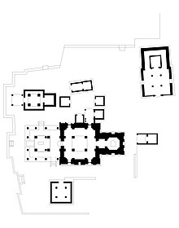

[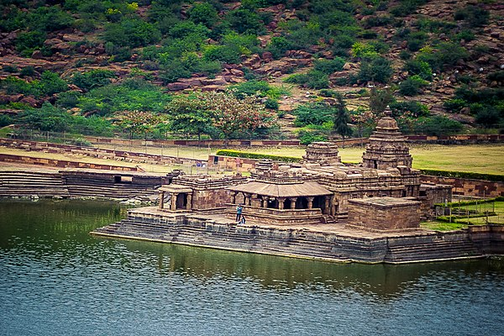](https://en.wikipedia.org/wiki/File:Bhutanatha_group_of_temples,_Badami,_Karnataka.jpg)

**GOAL**

The Bhutanatha group of temples comprises of a bunch of sandstone

temples, all dedicated to Lord Shiva and his disciples.

[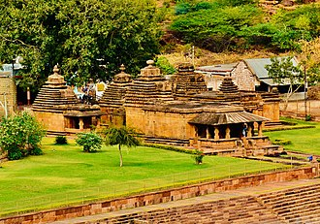](https://en.wikipedia.org/wiki/File:11th_to_12th_century_Northern_Bhutanatha_group,_Mallikarjuna_temples,_Badami_Karnataka.jpg)

Temples in the Mallikarjuna group, also called the north Bhutanatha group.

The Mallikarjuna group is close to the main Bhutanatha group but located on the north back of the manmade lake. It consists of several temples. These open to the south and are marked by their notable pyramidal superstructure in the 11th to 12th-century *phamsana* Nagara style. The largest temple likely was a Vishnu temple, saw a period when these ruined temples were in disuse, and was re-consecrated with Shiva linga while preserving the remains of its historic artwork. These temples present the construction ideas explored by the Kalyani Chalukya architects. The largest temple has an open rectangular mandapa with eight pillars, that connects to an inner mandapa, antarala and garbhagriya – all on a square plan. All temples in this group have simpler walls, angled eaves over the open *mantapa* (hall). The artwork found in this group includes both Vishnu and Shiva.

**LOCATION**

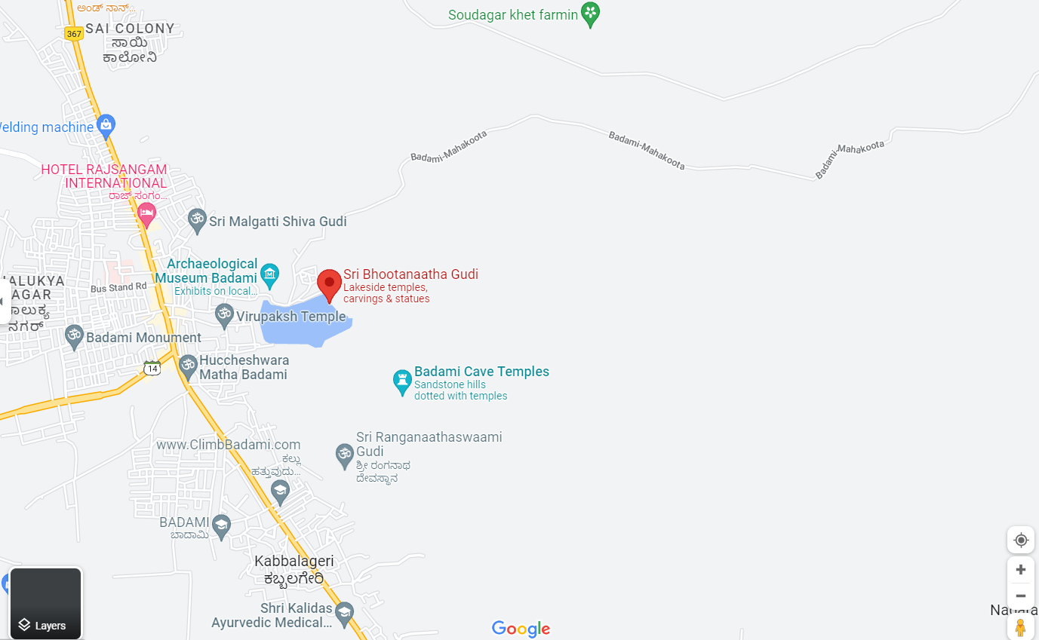

**CHAPTER 5**

**AGASTYA LAKE**

At a distance of 1 Kms from Badami Bus Station, The Agastya Lake (Tirtha) is a huge lake located beneath the cave temples. Constructed in 5th century, the lake is considered holy due to the healing powers of its water.  
  
The eastern banks of the Agasthya Lake are dotted with Bhoothanatha temples while the caves temples are located on Southwest part and the fort on Northwest end. According to puranas, The Pushkarini was a pleasure tank of God in Vaikunta and is a beloved of Lakshmidevi and Bhoodevi. The Pushkarini was brought and set here by Garuda, the vehicle of Lord Vishnu. A bath in it is believed to destroy all sins.  
  
The lake is usually crowded by the village residents for washing cloths and bath. The quality of water is okay but not a good place to swim. The surroundings of the lake provide great views of the hills surrounded by the historical monuments. The Bhoothanatha temple which is emerged into the lake is a beautiful sight with a backdrop of large hillock. Some devotees shaved their heads after the first initiation. First second initiation was in Boston, May 9, 1968 where only male devotees were initiated. However next day saw a number of women initiated too.

**HISTORY**

The Pushkarini was a swimming tank that was source of immense pleasure for the divine and was specially favoured by Lakshmi & Bhoodevi, the wives of Lord Vishnu. The Pushkarini is believed to have been transported to mortal world by Lord Vishnu's vehicle the Garuda bird and hence the Agastya Lake is believed to be the same pleasure tank on earth and carries a reputation cleansing sin of those who take a dip in it.

**LOCATION**

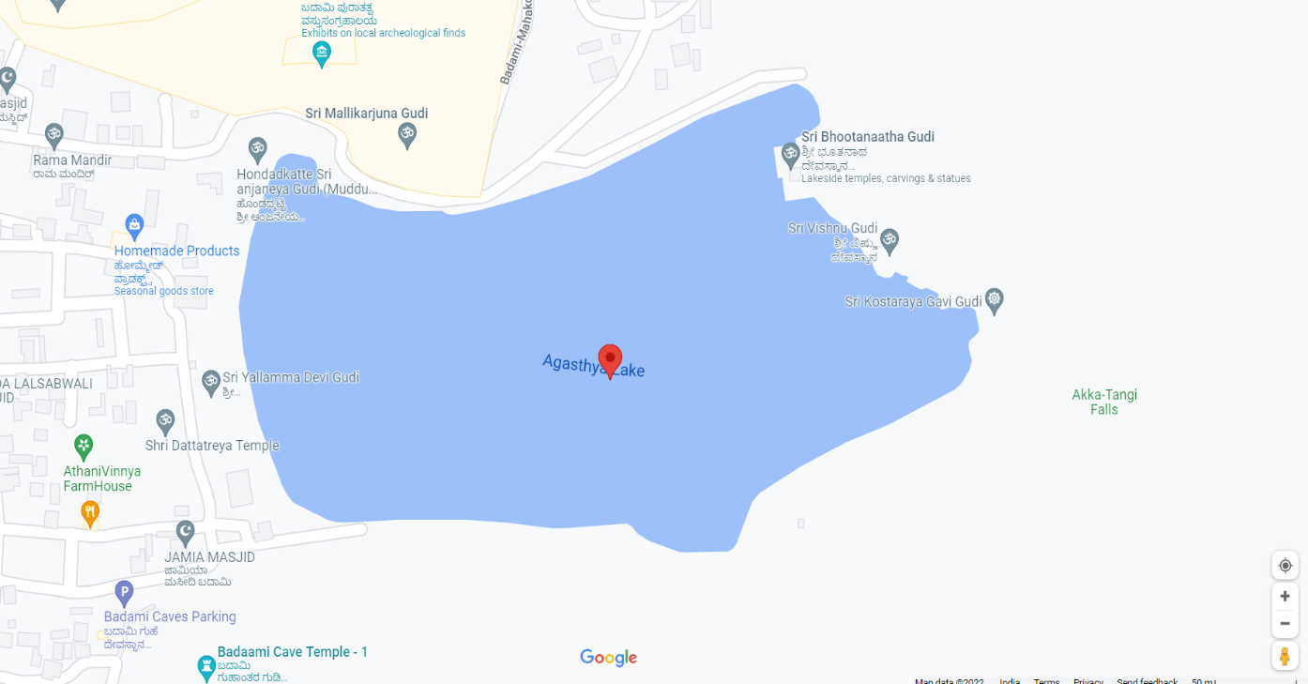

**CHAPTER 6**

**ARCHEOLOGICAL MUSEUM**

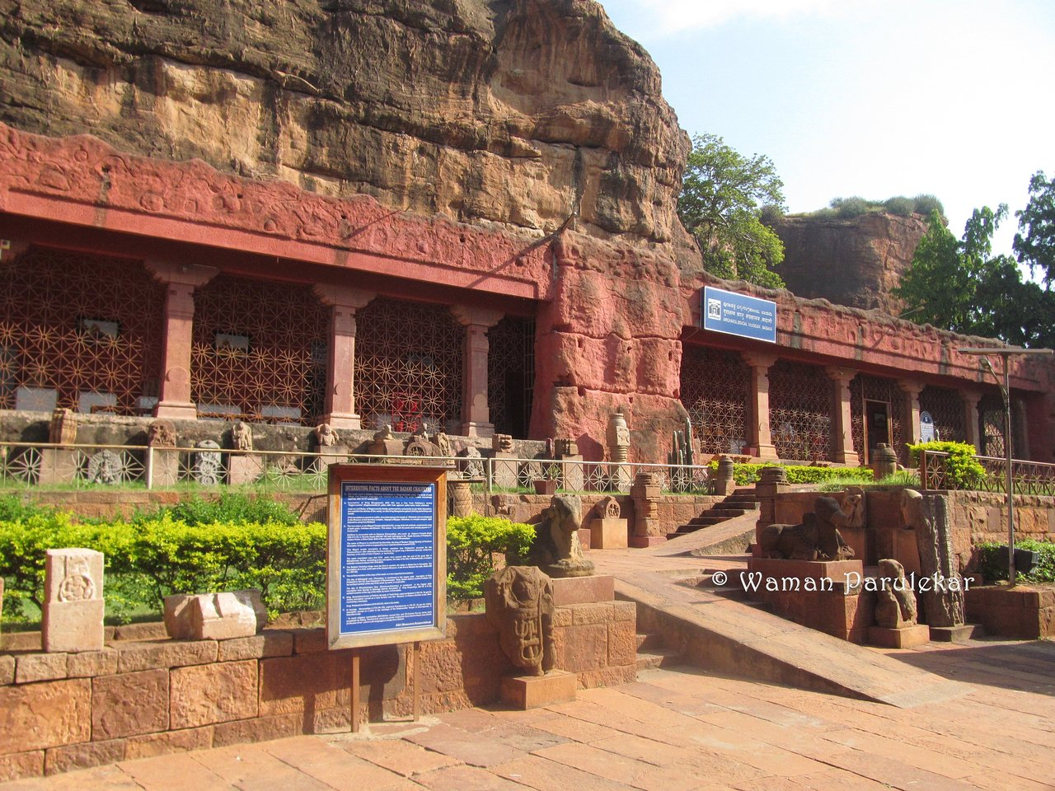

The Archaeological Museum was established in the year 1982 houses 181 antiquities including sculptures, decorated architectural members and inscriptions found in and around Badami. There are four galleries in the museum and surrounded by an Open-Air gallery. At the entrance, is an open-air gallery presenting Jaina image, Nataraja, Nandi, kirtimukha, erotic figures and some decorated architectural members.  
There are four well-furnished galleries, which includes exhibits such as – attractive makaratorana-carved on both sides, Siva represented as Kalari, Tripurantaka, Bhairava and Nataraja and Vishnu as Narasimha, Female divinities (Lajja-gauri, matrikās, Bhairavi and others).  
The panels depicting Bhāgavata or Krishnalilā scenes are outstanding specimens. The large, scaled model of the prehistoric cave at Shidlaphadi, the trans-slides depicting the various aspects of pre-historic life and the newly organized section exhibit human evolution, pre-historic paintings, and stone implements, are important attraction of this museum. The section on conservation, excavation, epigraphy, and the newly discovered quarry site along with iron implements, etc. are highly educative and highlight the multifaceted culture of Badami. A rare line drawing of the paintings in cave-III is yet another important exhibit in the museum. Trilingual Audio Video film information is available in the museum.  
Apart from this, the museum has departmental publication sales counter and reference library with good number of collection of books regarding art and architecture.

Entrance Fee Rs. 5/- per head (free for Children up to 15 years)

Time: from 09.00 AM to 5.00.PM.

(CLOSED ON FRIDAY)

**Contact Details:**  
**Shri R.N.Kumaran**

Assistant Superintending Archaeologist  
Archaeological Museum,

Archaeological Survey of India,

Badami – 587 201,  
District Bagalkot, Karnataka  
Ph: 08357-200057  
E-mail: mus.badami@gmail.com

**LOCATION**

